**Technical Assignment Report**

**Author:** Amin Khodamoradi  
**Date:** 14/06/2025

**Objective**

The objective of this assignment was to build a text classification pipeline that:

* Classifies texts into one of the following categories: cult, paranormal, or dramatic (using task.csv).
* Offers a demo web interface for prediction using Gradio.
* Provides a REST API for programmatic access using FastAPI.
* Is containerized via Docker for consistent deployment.
* Optionally, extends to a multi-label classification using bonus_task.csv.

**Step 1: Data Investigation**

The dataset task.csv contained movie metadata with the following columns:

* Title: Movie title
* Synopsis: Movie description (used for classification)
* Tag: Ground-truth category

Basic statistics and value counts were extracted to understand class distribution.

**Step 2: Preprocessing**

* Converted all text to lowercase.
* Removed special characters and punctuation using regex.
* Created a clean_synopsis column for the cleaned text.
* Encoded the Tag labels using LabelEncoder into numeric format.

**Step 3: Train-Test Split**

Used an 80/20 split on the cleaned synopsis and encoded labels:

* X_train, X_test: Vectorized text features
* y_train, y_test: Encoded class labels

Stratification was used to preserve label distribution.

**Step 4: Feature Engineering (TF-IDF)**

Used TfidfVectorizer to convert cleaned text into numerical feature vectors:

* Max features: 5000
* Fitted on training data, transformed both train and test sets

**Step 5: Model Training and Evaluation**

Trained a logistic regression model (LogisticRegression) as a baseline classifier.  
Other models such as RandomForestClassifier and GradientBoostingClassifier were explored.

Evaluation metrics:

* Precision, Recall, F1-score (using classification_report)
* Label decoding used to interpret predictions

precision recall f1-score support

cult 0.72 0.97 0.83 207

dramatic 1.00 0.03 0.06 34

paranormal 0.82 0.38 0.52 73

accuracy 0.73 314

macro avg 0.85 0.46 0.47 314

weighted avg 0.77 0.73 0.67 314

**Step 6: Gradio Demo App**

Developed a user-friendly demo with Gradio:

* Allows users to input/paste text
* Displays predicted category in real-time
* Bound to 0.0.0.0:7860 for Docker networking

**Step 7: FastAPI REST API**

Built a REST endpoint /predict using FastAPI:

* Accepts JSON payload: { "text": "your input here" }
* Returns: { "prediction": "cult" }

Tested with Swagger UI (/docs) and PowerShell Invoke-RestMethod.



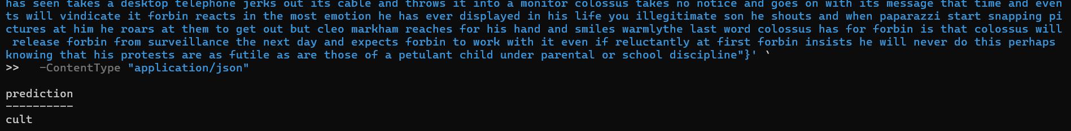

**Step 8: Dockerization**

Created a Dockerfile to package the app:

* Python 3.11.3 base image
* Installs dependencies via requirements.txt
* Exposes ports 8000 (API) and 7860 (Gradio)
* Entrypoint defaults to FastAPI, but Gradio can be run with CMD override

**Step 9: Docker Compose (Run Both Services Together)**

Used docker-compose.yml to run both FastAPI and Gradio apps concurrently:

* fastapi_service at port 8000
* gradio_service at port 7860
* Shared image and codebase

**Bonus (Not Implemented Yet)**

The bonus task involves using bonus_task.csv for **multi-label classification**.  
The plan is to:

* Use transformers to embed the text
* Create a RAG to tag the input text

**Tools & Libraries Used**

* Python 3.11
* pandas, scikit-learn
* Gradio
* FastAPI
* Docker & Docker Compose

**Conclusion**

The project demonstrates a complete NLP deployment pipeline:

* Preprocessing & training
* Evaluation
* Real-time demo (Gradio)
* API integration (FastAPI)
* Scalable deployment (Docker Compose)

This solution is modular and extensible — ready to integrate bonus multi-label support or scale with larger models like BERT and Transformers.